**Propagation and backscattering challenges for planar polarimetric phased array radars**

D. S. Zrnic1, R.J. Doviak1, G. Zhang2, Y. Zhang2, and C. Fulton2

1National Severe Storms Laboratory, NOAA, Oklahoma

2Radar Innovation Laboratory, University of Oklahoma

**Abstract**

Estimating the polarimetric variables with planar phased array radars requires calibration at every pointing direction. In the principal planes calibration is relatively simple. This is because to first order the transmitted fields from two radiators that determine the polarization are orthogonal and if the array is in the vertical plane there is no coupling through propagation and backscattering by rain. This means that separate calibration of each channel can be made. If the pointing direction is outside the principal planes and/or the plane of the array is tilted, the polarization of the transmitted wave in general has both the horizontal (H) and the vertical (V) components, even if only the H or V port is excited. In that case, the estimates of the polarimetric variables incur a geometrically induced bias which is affected by transmitted wave characteristics, propagation, and backscattering. The fundamental challenge is to devise a planar polarimetric PAR that can overcome this geometrically induced bias. Design alternatives that mitigate this bias are presented herein. These are: a) Antennas for which the V radiating element is an electric dipole and the horizontally radiating element is a magnetic dipole. b) Combined use of the antenna ports so that the transmitted field is composed of equal horizontal and vertical component. c) Constrained measurements within a narrow range of directions close to the principal planes. d) Alternate transmission but simultaneous reception through the two ports. e) Phase coding of the transmitted signals in each port. The maturities of these alternatives as well as the relative merits are discussed.

**1. Introduction**

We consider a planar phased array (PAR) radar antenna with dual polarization. Specifically, we assume that the Port 1 produces the intended horizontally (H) polarized field and the Port 2 generates the intended vertically (V) polarized field. It is impossible to produce pure horizontal or vertical field within the beam at all pointing direction with elements of the same type. The distribution of the cross-polar field within the beam depends on the physical structure of the radiating element and the direction of the beam.

If the elements are of the same type, then the cross-polar field in the principal planes would ideally be zero. If the copolar beam is in the principal plane, then the cross-polar field at beam center is zero. But if the beam is steered out of the principal plane the cross-polar field will have one prominent peak at or near beam center (i.e., the cross-polar beam’s axis nearly coincides with the axis of the copolar beam). This peak is geometrically induced. It has been demonstrated (Zrnic et al. 2010) that it can cause significant bias in the polarimetric variables.

**2. Designs to mitigate geometric bias (tilted array)**

If the plane of the array is tilted the intended H polarized fields will be at an angle with respect to the horizontal axis and the intended V field will no longer lie in the vertical plane. This will cause bias in the polarimetric variables and various methods aimed at reducing the effect of this bias are discussed next.

*a*) *Collinear magnetic and electric dipoles*

First consider the dipole array is not tilted. The vertically oriented electric dipoles produce an electric field oriented along the meridional lines of the radiation sphere that has a vertical polar axis centered on the array. Thus the electric field lies in vertical planes containing the polar axis. Although the field orientation is truly vertical only at the zero elevation angle, this is not detrimental to polarimetric measurements at low elevation angles where the small departure from the vertical causes insignificant bias in differential reflectivity. Vertical magnetic dipoles produce a field parallel to horizontal planes. If the electric and magnetic dipoles are collinear the intended H and V fields at every pointing direction are orthogonal. Therefore, the PAR antenna comprised of collinear magnetic and electric dipoles will produce orthogonal H and V fields in all pointing directions (Crain and Staiman 2009). Nonetheless, if the array is tilted the intended H field (out of the principal vertical plane) will not be horizontal and similarly the intended V filed will not be “vertical”. The physical layout of such dipoles is three dimensional and the developments so far were exploratory.

*b*) *Antennas with patch radiators*

Excitation of Port 1 for radiating the H field (by the vertical sides of the patch) also causes radiation of the V field from the horizontal sides (Bhardwaj and Rahmat-Samii 2014). This radiation creates a cross-polar pattern which at broadside has four symmetric peaks of equal intensity but opposite sign (two of the same sign along each diagonal cut). In this case if the cross-polar peaks are at least 25 dB weaker than the co-polar peak, the first order bias (proportional to the one way cross-polar field) in the polarimetric variables is null and the ZDR bias is insignificant (Zrnic et al. 2010). For beams in the principal planes (away from broadside) a pair of these cross-polar peaks shifts towards the beam center location and is symmetrically split with respect to the principal plane of the scan; the other pair diminishes in intensity. Again if the peaks’ intensity is more than 25 dB below the copolar peak the bias is insignificant. If the beam is steered away from the principal planes a single cross-polar peak collinear with the copolar one is created causing significant bias. Special designs might reduce the cross-pol radiation so that its effects on the polarimetric variables are acceptable. Regardless if this can be achieved or not, the cross-polar fields generated by the cross-polar radiating sides are not considered here. We concentrate on the “geometrically” induced cross-pol radiation associated with the copolar radiating sides.

In Fig. 1 the orientation of the electric field at beam center  is plotted for a tilted array and pointing out of the principal vertical plane. The geometry also applies to a vertical array pointing out of the principal planes.

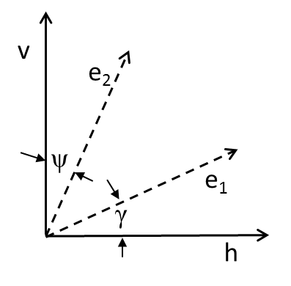

Fig. 1. The horizontal (h) and vertical (v) axis in the polarization plane of a propagating EM wave. The axis h is parallel to the ground; because of earths curvature the axis v is approximately vertical with respect to earth only if the elevation angle is zero and observation is close to the radar. The axis  and indicate the direction of the fields *E*1, *E*2 at beam center generated by the ports 1 and 2.

Rather than using the copolar (one-way) field pattern functions of Zrnic et al. (2010)

, etc. (1a)

we use

 (1b)

and , (1c)

to designate the magnitudes of the electric fields (in the far field region) at beam center. For weather observations in which the radiation sphere’s polar axis is aligned with the vertical direction, the gain in any direction also depends on the beam direction.

We assume (with no loss in substance) that in the broadside direction the two ports produce the same field magnitudes (this needs to be calibrated in the backend of the antenna) but have a difference in phase (on transmission) *β.* This difference may vary with the pointing angle. If a phase code *c*(*n*) is applied to mitigate the effects of coupling (Zrnic et al. 2014) this difference would be a function of *nT*s and can be expressed as *β*(*n*) = *β*o + *c*(*n*). Furthermore, assume propagation through media of oriented oblate scatterers produces differential phase *Φ*DP. For compactness let’s use and similarly  where the summation is over the scatters (*i* index in the elemental volume Δ*V6*) ) and the range to the scatterer is *ri*. The *shi* is the element of the backscattering matrix for the horizontally polarized incident field; assume oblate spheroids (no depolarization) hence in the usual notation (*a* symmetry axis, *b* long axis) the *shi* = *sbi*. Moreover, the range dependence and reshuffling are implicit in the summation but omitted for brevity sake. The matrix transformation **P** relating the variables e1,e2 to the variables h,v (Fig. 1) is

. (2)

Ignoring cross-polarization components induced in propagation, scattering and antenna, the received voltage *δV*1 (corresponding to the intended H field) and *δV*2 (intended V field) from the elemental volume are

(3)

The following explains various assumptions in (3). Although *S*v is complex we set it to be real because its phase is an inconsequential reference. Therefore, *S*h = | *S*h|exp(-*jΦ*DP) so that the effects of differential phase *Φ*DP from propagation and backscatter are accounted for. *C* is the calibration parameter. *W*1 is the voltage at Port 1 generating the field *E*1 and *W*2 = *CTejβW*1is the voltage at Port 2 generating *E*2. The phase difference on reception between the outputs from Port 2 and Port 1 is *ξ* and the ratio of amplitudes (Port 2 to Port 1) equals *CR*. On the right side the explicit dependences of *g*1, *g*2 on direction hold but are dropped to fit the equation.

Regroup the terms in (3) as follows



Equations (3) and (4) apply to any elemental volume within the resolution volume. But if the beam is narrow as on polarimetric planar PAR (PPPAR) we can assume *g*1is equal to its value at beam center. Therefore, *for PPPAR beams steered away from the principal planes the orientation and magnitudes of the reflected fields can be obtained from the values at beam center* (Lei et al. 2015)*.* This is assumed in the sequel and the voltages from the elemental volumes are replaced with their sums *V*1 and *V*2 over the resolution volume.

In principle one can invert (4) to express the *S* coefficients in terms of the voltages. This requires knowledge of the orientation angles, *ψ* and *γ*, the phase differences *β* and *ξ,* and the Port 2 to Port 1 scaling factors on transmit *CT* and on receive *CR*, as well as the power gains *g*1 and *g*2 at every pointing direction. This amounts to eight numbers that need to be known plus the calibration parameter *C* for calculating voltages and hence reflectivity.

The voltages and *S* parameters change from pulse to pulse; say as function of the sample number *n* of the time series data. Thus the pulse to pulse inversion of (4) would generate two time sequences one for the *S*h(*n*) the other for the *S*v(*n*). From the average powers and , *Z*h and *Z*DR can be computed. From the correlation of the two sequences the differential phase *Φ*DP and correlation coefficient *ρ*hv can be computed. Although promising results of inversion on a small one dimensional array in a laboratory set up have been obtained (Fulton and Chappell 2010) there have been no demonstrations on larger arrays yet.

A different way to compute the second order moments () is from the powers of the returned signals at the Port 1 and Port 2, and the correlation of these two signals (i.e., the power estimates from the first row of (4) summed over *M* samples, similar power estimate from the second row and the estimates of the correlation between the first row and second row signals). The number of electric parameters that need to be known is also nine.

*c*) *Phase coding*

Phase coding can simplify somewhat this computation. Suppose that the 0o, 180o phase code is applied to the Port 2. This can be represented as *e jβ*(n) where *β*(*n*) changes between 0o, 180o. Fourier transform of the first row in (3) generates two spectra: one from the first term in row 1 is centered at the Doppler velocity the other (second term in row 1) is offset by the unambiguous velocity. Thus one can separate these two terms as follows:

 (5a)

, (5b)

whereis the sequence (measurement) obtained from the inverse Fourier transform of the spectral components corresponding to one half the Nyquist interval centered on the mean Doppler velocity . is the sequence corresponding to the spectrum offset by the unambiguous velocity from . Similarly the two terms in the second row of (3) can be separated so that the number of sequences is four. But the sequences corresponding to the off diagonal terms (i.e., cross polar) differ by a complex multiplying factor. Therefore there are three sequences which can be used to form powers and cross products. Of the three the one corresponding to the diagonal term is redundant hence might be useful for checking consistency or determining the initial transmitting phase.

The powers and cross product of separated diagonal sequences can be used to generate three complex equations in which the unknown terms are. The third term has the differential phase. It should be expressed as one complex number. In doing so one needs to track this number and its conjugate until the last step in the solution of the three complex equations. The angles *ψ* and *γ*, the differential phases *β*o and *ξ,* the gains and amplitude calibration of the two channels on transmit and receive need to be known in addition to *C*.

*d*) *Alternate transmission of the H and V field* (*AHV*)

Consideration of the AHV mode is analogous to the phased coding except the four terms in the matrix of (3) are separated if the cross polar component is recorded. The cross-polar signal at Port 2 (if only Port 1 is active) is the 21 term in (3) and if the Port 1 is active it is the 12 term in (3). These components are redundant but might be helpful to check stability of the system. Computations of the second order moments are made using the main diagonal terms in (3) which are estimated (measured) sequentially. Therefore, the correlation term includes the Doppler effect which needs to be eliminated (Zrnic et al. 2011). From the expression (13.9) the maximum values of the angles *ψ* and *γ* for which the bias in the polarimetric variables is acceptable can be determined.

*e*) *Measurements at directions close to the principal planes*

From the expression (3) the maximum values of the angles *ψ* and *γ* for which the bias in the polarimetric variables is acceptable can be determined.

**3. Vertically oriented array**

If the array is oriented vertically the angle *γ=*0 and corrections and computations become simpler. But the relation between the angle *ψ* and azimuth and elevation is needed it is given in the Appendix eq. (a.5). Herein we provide more details for this geometry about the computations than is listed in section 2.

*a*) *Relations (SHV mode)*

The governing relation (3) expressed as two equations is

 (6a)

. (6b)

Multiplying (6a) with  (from pulse to pulse) and subtracting from (6b) solves for the second term in (6b) which is

 (6c)

Therefore, the polarimetric variables can be estimated from (6a) and (6c).

By inspection it can be seen that if *β* = 0 and *ξ =*0, the differential phase can be computed directly by correlating the conjugate of (6a) with (6c) and that *ρ*hv equals the magnitude of the corresponding correlation coefficient. Besides the implicit dependence on the direction angle *ψ* of the intended V field the polarimetric variables from (6) depend explicitly on this angle through the values of *g*1 and *g*2.

Note that *Z*hand *Z*v [from (6a), (6b)] depend explicitly and implicitly (through 1b, 1c) on *ψ*. The *Z*DR depends on the same variables and is independent of *C* as it is proportional to the ratio (6a) to (6c).

The alternate way to compute the polarimetric variables is from the powers of (6a) and (6b) and the correlation between (6a) and (6b). From these, first theand

*Φ*DP are found and combined to generate the polarimetric variables. Thus, take the power estimates as average of *M* samples:

 (7a)

 (7b)

 . (7c)

From these equations it is evident that all the moments depend on the pointing direction explicitly and also implicitly through the equations (1b, 1c). Equation (7a) is not coupled to the other equations hence to compute *Z*hone only needs to integrate over the beam the width of which depends on the pointing direction. Again note that adjusting *β* and *ξ* to 0 simplifies the solving process. Assuming that the calibration is acceptable (the *C*, *CT*, *C*R and (1b) and (1c) are known as well as *ψ*) it is in principle relatively easy to solve the set (7) for the polarimetric variables. For example, (7b) can be properly scaled and added to (7c) so that the first term in (7c) is eliminated. Then the cross product can be computed. Subsequent substitution in (7b) yields. Next we examine the number of parameters needed for calibration.

Backend (behind the antenna): The gain *C* and the differential gain on transmission *CT* and the differential phase *β* and *ξ* add to 4 numbers (compare that to 2 gains for the dish antenna and the system differential phase *β* + *ξ* which can be obtained from data). Similar holds in the receiver channels, the differential gain *CR* and the differential phase *ξ*; note that the overall system calibration *C* lumps together all the gains and losses in both receiver and transmitter chain. This amounts to 2 more numbers (two gains in the receiver are needed for the dish antenna). We expect that these 5 numbers would be independent of the pointing direction.

Antenna: The gains, the corresponding beamwidth (the two patterns should have the same elliptical shape beam cross sections otherwise the weather PAR is dead on arrival), and the pointing direction *ψ*. This totals 4 but it may be safe to assume that the beamwidths (two needed for the elliptical shape) would be computed from the known pointing direction and the computed (calibrated via measurements) gains. That would reduce the number of “independent” variables to 3 for each pointing direction. To cover 90 degrees in azimuth and 15 elevations with a planar array, 1350 beam positions are needed. This translates to 4050 calibration numbers. Because of viewing symmetry (the left field of view is symmetric to the right one) the actual number to calibrate might reduce by a factor of 2, to 2025. Some other reductions in complexity are expected in and near the principal planes (at about less than 300 points).

*b*) *Simultaneous transmission with phase coding*

To condense notation, the signal centered on the mean Doppler in Port 1 is written as *V*11 the one in Port 2 is *V*22 and the cross-port signals (offset by the unambiguous velocity) are *V*12 (from Port 2 coupled to Port 1) and *V*21 (Port 1 to Port 2). Furthermore for consistency with the previous results, the relative calibration (ratio of) Port 2 to Port 1 voltage on transmission is denoted as ; this implies that *β*(*n*) = *βo* + *ejnπ*. Here the subscript “o” on *βo* is used to distinguish it from the *β* in the case of the alternate (AHV) mode. Upon reconstruction (separation of the components) the *ejnπ* term is not present. Set *γ=*0 in (5a) and (5b) to express *V*11 and *V*12 as

, (8a)

. (8b)

Separation of spectra from Port 2 (6b) isolates the first term spectrum from the other two terms. These two terms become

, (8c)

, (8d)

It is evident that *V12* ≠*V21.*

The equations in (8) represent a shorthand notation for these voltages at any one sample time and the four complex sequences (or four complex spectra) consist of *M* samples each.

The powers and correlation of the first three terms are

, (9a)

, (9b)

, (9c)

, (9d)

, (9e)

Inspection reveals that some relations between four parameters can be obtained easily, and are independent of *C,* *W*1, *g*1, *g*2, and sin(*ψ*). These are: the phases *βo* and *ξ* from the arguments of (9d) and (9e), and thus the system differential phase *Φ*DPsys= *βo* + *ξ,* and the ratio *CT/CR* by dividing (9d) with (9e), or (9b) with (9c) which is redundant and can be used for cross checking.

Phase coding is more effective if the unambiguous velocity interval is significantly larger than the spectrum width of the weather signal so that the two offset spectral components can be well separated in the frequency domain. Otherwise the original and offset spectra of weather signals would overlap precluding clean separation.

1) POLARIMETRIC VARIABLES

Computation of the polarimetric variables in case of a vertically oriented array is presented in this section. Errors introduced by various approximations are evaluated and fields of view in azimuth and elevation where the errors are tolerable are plotted.

(*i*) *Differential reflectivity*

The differential reflectivity can be computed as follows

. (10a)

Take  or

, (10b)

and substitute (10b) in (10a) to obtain

. (10c)

Then take

, (10d)

and note that the *βo* and *ξ* are available in (9d) and (9e), therefore they can be removed from (10d); also  from (9a) can be substituted in (10d) so that the can be computed. With this, one can solve for  as follows

, (10e)

and combine with (9a) to compute *Zdr.* The peril in this approach is that the coefficients entering these equations (through *Bpc* and other) need to be known.

It may be tempting to use *Bpc* in (10c) directly to estimate *Zdr* as , (10f)

in which the bias is the denominator. Note the sin4(*ψ*) in the denominator of (10c). Because *ψ* is small, computation of (10c) may be problematic. If scans are in or near the principal planes one can avoid this problem by computing the parameters *g*1, *g*2, C*T*, and *CR* and using these in (10a). By inspection it is obvious that if these parameters are known the envelope of the acceptable bias would be the same as when the *Z*DR is computed from (10c). At what point to transition from (10a) to (10c) will depend on the relative contribution of errors from the uncertainty in the parameters versus the contribution from the error in the uncertainty of the angle *ψ*.

For illustration, the field of view where the bias of *Z*DR is acceptable is examined next. This is made under the following conditions. The *Z*DR values of 0, 1, and 2 dB; *ρ*hv values of 0.5 and 1, and *Φ*DP of 0 and 180o are tested. The triplet *Z*DR = 2dB, *ρ*hv = 1, and *Φ*DP = 0o produces the largest field of view (Fig. 2a) and the triplet *Z*DR = 2dB, *Φ*DP = 180o, and *ρ*hv = 1 produces the smallest field of view (Fig. 2b). In these and subsequent figures only the first quadrant of the field of view is presented because the total field of view is symmetric with respect to the abscissa and the ordinate.

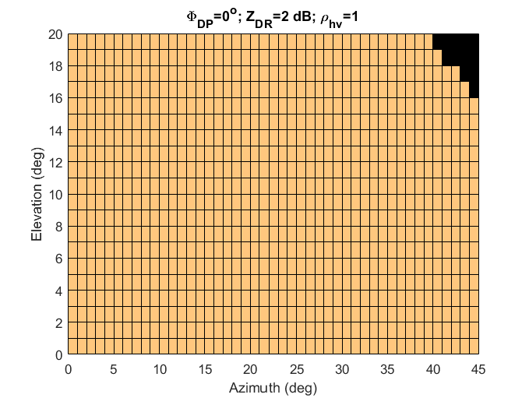 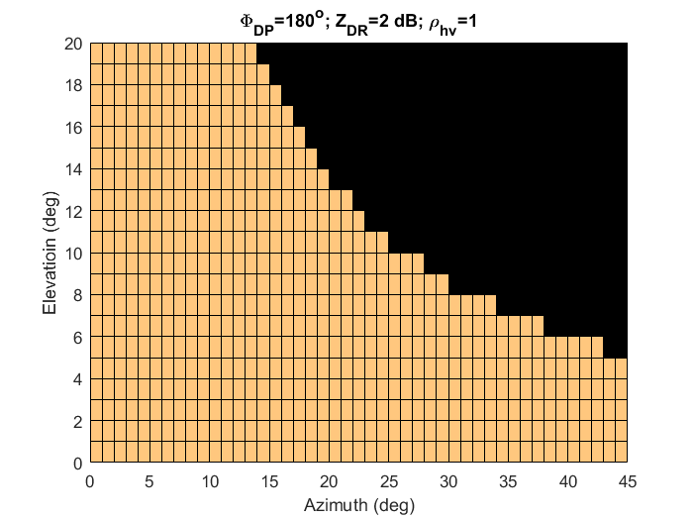

Fig. 2 Left: the field of view in azimuth and elevation where the bias in *Z*DR is smaller than 0.1 dB. *Z*DR is computed from (10c.) and the triplet *Z*DR = 2dB, *Φ*DP = 0o, and *ρ*hv = 1 is assumed in (10c) and it produces the largest field of view. Right: the equation (10c) is used to compute *Z*DR and it produces the smallest field of view for the following triplet: *Z*DR = 2dB, *Φ*DP = 180o, and *ρ*hv = 1. The *Z*DR bias is constrained to be less than 0.1 dB.

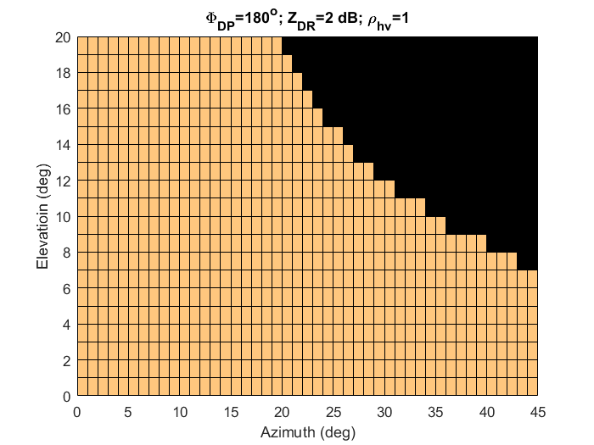

Relaxing the *Z*DR bias uper bound to 0.13 dB, and keeping the triplet (*Z*DR = 2dB, *Φ*DP = 0o, *ρ*hv = 1) which produced largest view in Fig. 2 a) gave a clear field of view for elevations up to 20o and all azimuths. Relaxing the bias to 0.2 dB increases marginally the smallest field of view (Fig. 3)

Fig. 3 Same as Fig. 2 Right, but the *Z*DR bias is constrained to be less than 0.2 dB.

(*ii*) Correlation coefficient

For the vertically oriented antenna and phase coding with filtering the four components of voltages in (8) are available. Then the approximate relation for computing the correlation coefficient is

, (11)

and it is compatible with the approximation (10a) for computing *Z*DR. It is obvious this relation is independent of the various gains, but it produces a biased estimate of *ρ*hv dependent on the polarimetric variables and pointing direction. By substituting the values for *V*11 and *V*22, (8a and 8d) and taking ensemble averages of the powers and correlations the *ρ*hv estimate becomes

. (12)

Subtracting (12) from the true *ρhv* reveals the bias. Therefore

. (13)

The bias (13) depends on several parameters and can be positive or negative. At *Φ*DP =180o the bias has maximum positive value. At high values of *ρ*hv near 1 (0.96 to 0,99) a change of 0.01 can signify significant difference in types of scatterers. That is why the errors for the WSR-88D are specified to be less than 0.003. Assuming this value one can compute the field of view (Fig. 4) within which the bias is acceptable. Maximum values of bias occur at *Φ*DP of 0o and 180o and these maximums becomes larger as *ρ*hv decreases and *Z*DR increases. We chose *ρ*hv of 0.96, a value at the transition between rain (or snow) and the melting layer because the gradients at this and higher values are sensitive to the hydrometeor types. Lower *ρ*hv indicates mostly non-meteorological scatterers (with the exception of hail) and in that range larger errors can be tolerated. We use *Z*DR = 4 dB as an upper representative value for precipitation like growing dendrites or melting graupel. Clearly the fields of view are similar and compatible.

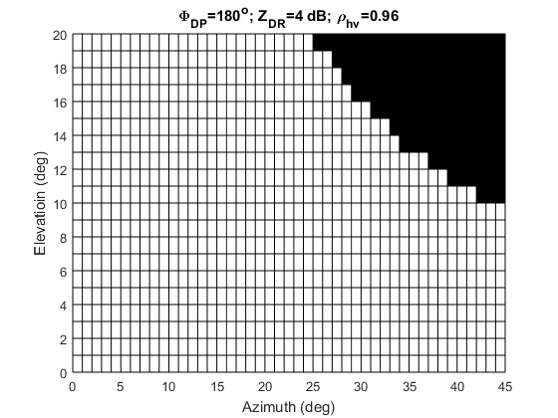 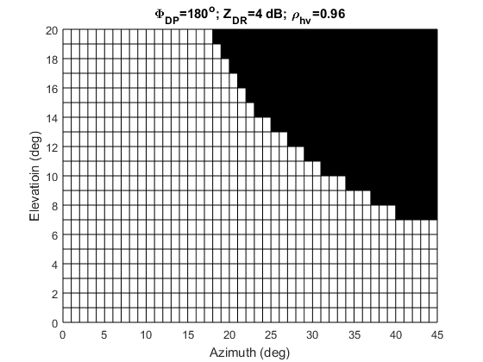

Fig. 4 Field of view (left) where the *ρ*hv |bias| <0.003 in the SHV mode with phase coding or AHV mode. The plot is valid for *Φ*DP=180o, *Z*DR = 4 dB, and *ρ*hv =0.96. Right: the field of view where the bias in *Z*DR is smaller than 0.2 dB and the other parameters are the same as in the left panel.

(*iii*) *Differential phase*

Similar to and consistent with computations of *Z*DR and *ρ*hv we can approximate the differential phase by the argument of the right side of (11). It is

, or (14a)

. (14b)

The bias  has a maximum if *Φ*DP is 90o multiplied with an odd number. For the same parameters as in Fig. 4 and acceptable bias of 1o or 2o the fields of view are plotted in Fig. 5.

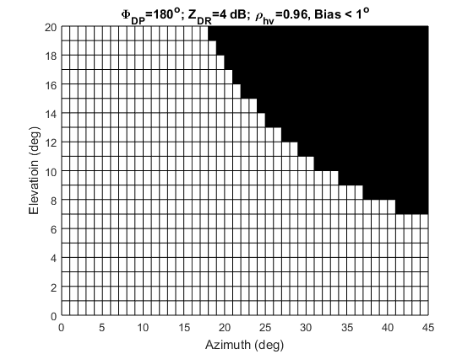 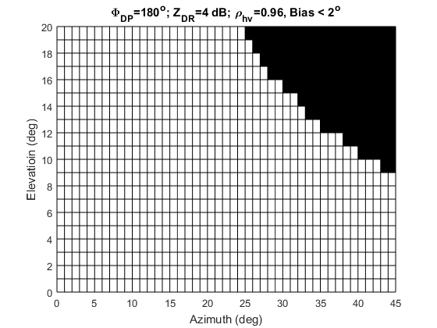

Fig. 5 Field of view (left) where the *Φ*DP |bias| <1o in the SHV mode with phase coding or AHV mode. The plot is valid for *Φ*DP=90o, *Z*DR = 4 dB, and *ρ*hv =0.96. Right: same as in the left panel except the *Φ*DP |bias| <2o.

*c) Simultaneous transmission without phase coding*

Herein the field of view is examined in case of no phase coding. Thus, the *Z*dr is computed from equations (8) as

. (15)

Evaluation of (15) demonstrates the size of the field of view depends heavily on the combination of the differential phase *Φ*DP and the differential phase on transmission *β*. It has insignificant dependence on the true values of *Z*DR (i.e., between 0 and 2 dB) and *ρ*hv (between 0.5 and 1). For illustration the fields of view in which the |bias| is smaller than 0.1 are plotted in Fig. 6. In Fig. 6a the *Φ*DP=0o, *β* =85o whereas in Fig. 6b the *Φ*DP=180o, *β* =5o. Careful comparison of the two figures reveals that the only difference is at az=16, el=2 deg whereby the pixel in the Fig. 6a has bias smaller than 0.1 dB whereas in Fig. 6b the bias is larger. This indicates that there is no fixed optimum value for the differential phase on transmission *β*. The optimum depends on *Φ*DP which can have any value. Relaxing the bias to 0.2 dB produces Fig.7.

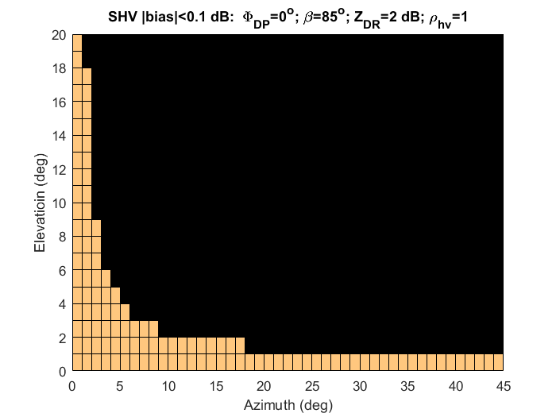 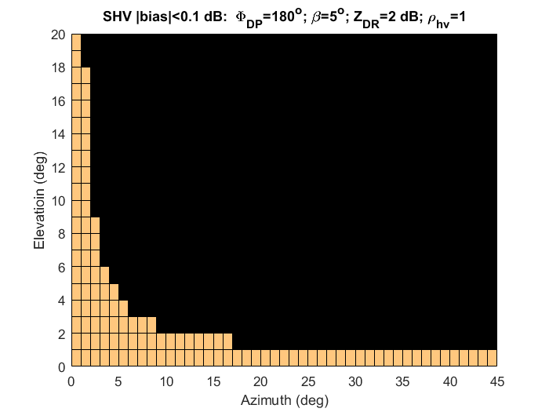

1. (b)

Fig. 6. a) Field of view where the *ZDR* |bias| <0.1 in the SHV mode, and no phase coding. The *Φ*DP=0o and *β* =85o are listed in the heading together with the other parameters. b) Same as in a) except *Φ*DP=180o, *β* =5o.

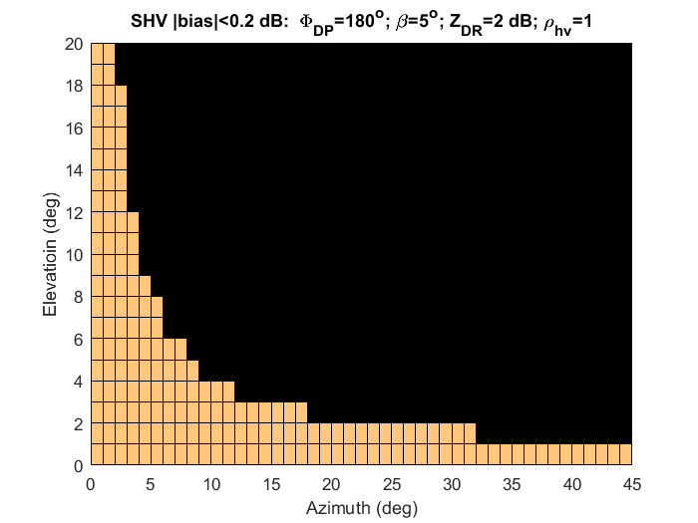

Fig. 7. Same as Fig. 6b except the bias in *Z*DR is specified to be <0.2 dB.

*d*) *Alternate transmission AHV*

The second order moments of voltages in case of the AHV mode are given with similar expressions as (9) except that there are some slight differences due to the effects of Doppler shift between successive returns (see Zrnic et al. 2010). The essence is demonstrated on pairs of pulses as follows (Fig. 8).

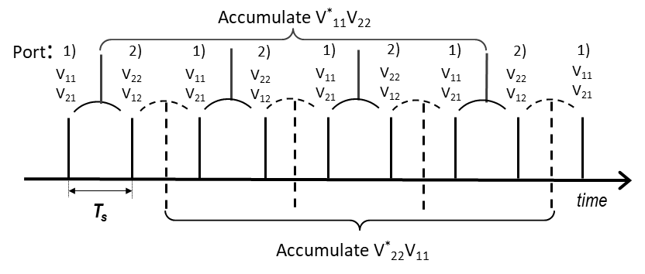

Fig. 8. Sequence of returns. Ports 1) and 2) are exited sequentially but the returns are received by both. That is Port 1 transmits and received V11 while Port 2 receives the coupled component V21. Then Port 2 transmits and so on. Products  are indicated with solid arcs and these are accumulated. Similarly the products are indicated with dashed arcs and are accumulated.

Assume that the sequence starts with the *V*11 so that the accumulation of pairs exemplified with would have a positive Doppler phase *Ψ*d. Thus we write

 (16a)

and

, (16b)

where *ρ* is the temporal correlation coefficient at lag *T*s. The accumulation in (16a) starts from the zeroth pair and takes every second pair (all even pairs) and in (16b) it starts with the odd pair (first) and accumulates all the odd pairs (Sachidananda and Zrnic 1989).

The products of copolar Port 1 and offset (by lag 1) cross polar (Port 2) returns are:

for even pairs

 (17a)

and for odd pairs

. (17b)

The product of copolar Port 1 and cross polar returns (from Port 1 in Port 2 at the same time) is

 (17c)

The spectrum width is retrieved from *ρ* (ratio of magnitudes (17b) and (17c)), *ξ* is the argument of (17c) which after substitution in (17a) retrieves the Doppler phase *Ψ*d. Because these relations are proportional to sin(*ψ*) they may be inaccurate at small *ψ* and small SNR. Thus, if scans are in or near the principal planes one can use (10a) directly. But then the four parameters *g*1,*g*2, *CT*, and *CR*must be determined.

Similarly, the relations involving *V*22 are for

even pairs:

 (18a)

odd pairs:

. (18b)

The product of copolar Port 2 and cross polar returns (from Port 2 in Port 1 at the same time) is

. (18c)

Now it is possible to obtain the same approximate relation (10f) for *Z*DR as follows. Compute *ρ* from the ratio of magnitudes, i.e., divide the magnitude of (18b) with the magnitude of (18c). Then divide (17b) with *ρ* and form the product . Dividing this product with the power of (8a) squared produces

 (19)

which is the same as (10b). Thus one can proceed as in (10c) and compute *Z*DR.

*c) Principal planes*

Calibration for the principal planes simplifies considerably as can be seen from the equations (6a) and (6b) after substituting *γ*=0 and *ψ=*0. The simplified forms become

 (20a)

and

. (20b)

Because it is assumed that coupling is insignificant only the product of terms in (20) needs to be calibrated (known) to obtain reflectivity and differential reflectivity. These products are functions of azimuth for the horizontal principal plane or elevation for the vertical one. Therefore, calibration becomes analogous to the one on the radar with a parabolic dish antenna except it needs to be done at each beam position because both *g*1 and *g*2 depend on the pointing direction.

According to Balanis (1997) the gains *gp*1and *gp*2 of patch antenna are

in the V principal plane:  and , and

in the H principal plane:  and .

Although these relations are closed form they will not apply exactly in practice hence the gain dependence on the pointing direction should be measured or simulated.

**4. Tilted antenna array**

For a tilted antenna array both angles *ψ* and *γ* must be known. The dependence of *ψ* on azimuth and elevation is the same as for the vertically pointed array and the relation between *γ* and azimuth and elevation is derived in the Appendix.

The most demanding requirement for phased array weather radar is to match the polarimetric performance of the WSR-88D at the lowest elevation scans. This is because in these scans the SHV mode and the long PRT (about 3 ms) are used. At broadside the cross-polar pattern of the WSR-88D has four symmetric lobes with respect to beam center and therefore the cross coupling through the antenna in the SHV mode is small (the bias in the polarimetric variables is acceptable). The long PRT avoids range ambiguities in the polarimetric variables while the SHV mode ensures the standard deviations of the polarimetric variables are small (Melnikov and Zrnic 2015). Here it is suggested how to replicate performance of the WSR-88D at the lowest elevations with the tilted phased array antenna.

Assume that tilt angle *θ*o with respect to the vertical *z* axis is small and use the voltages at Port 1 and Port 2 (*V*1 and *V*2 in 4) with no adjustment to compute the polarimetric variables. For this to hold the contributions by the “non-radiating” sides of the patch to the copolar powers and correlations must be small (similar to the ones on a parabolic dish antenna). We expect this will hold close to the principal planes (i.e., assume the main beam lobe encompasses the lowest elevation angles below beam center). In (4) take the multiplier *g*1 of cos2*γ* of the equation for *V*1 and divide with the multiplier of cos2*ψ* of the equation for *V*2. This number squared equalsand needs to be determined. Ideally it should be 1, if not the deviation causes constant bias to *Z*DR. Let’s assume it is 1, and *CR =CT* =1, and *g*1=*g*2. Then we can find the bias in the polarimetric variables computed from *V*1 and *V*2 in (4) by comparison with unbiased variables. The field of view can be obtained by inserting the relation between the *ψ*, *γ* and azimuth, elevation pairs (Appendix). The bias depends on the intrinsic values of the polarimetric variables.

In Fig. 9a is the field of view (worst case) where the *Z*DR bias is less than 0.1 dB for a small tilt of *θ*o =1.5o. The strip from 20o to 45o of larger bias is caused by the effects of non- orthogonality of the two fields and deviation of the intended horizontally polarized field from the true horizontal direction. Increase of allowed bias to 0.2 dB almost clears the bias at 0.5o elevation and expends the field of to 2o in elevation almost everywhere.

 

Fig. 9. The plane of the array is tilted by 1.5o with respect to the vertical. Left: The field of view where the *Z*DR bias is less than 0.1 dB. The intrinsic polarimetric variables and the differential phase on transmission β are listed at the top. Right: Same as in the left panel except the *Z*DR bias is less than 0.2 dB.

**5. Conclusions**

The calibration considered here is for the array that consists of patch radiators. It is assumed that calibration can be obtained from the gains at beam center. Furthermore, the effects of cross coupling due to cross-polar radiation of the patches is ignored so that the main contribution to biases comes from a) the non-orthogonality of intended H and V and b) from non-collinearity of the intended H with the true H direction and/or non-collinearity of the intended V with the true V direction. It is demonstrated that nine calibration parameters are needed to construct a set of linear equations relating second order moments of the received signals (at Ports 1, and 2 corresponding to intended H and V polarizations) to the pertinent elements of the polarimetric covariance matrix. Depending on the orientation of the array and the beam pointing direction the number of parameters and the solving complexity change.

To further quantify the challenge of dual pol measurements with the PPAR we consider a vertically oriented planar array and investigate three modes of operation. We define the field of view in the azimuth elevation plane as the region where the bias in differential reflectivity is below a prescribed value (0.1 dB). The size of the field of view is defined as a metric for comparison. Similarly, we consider a slightly tilted antenna array. We show the fields of view for which it suffices to extend the simpler solutions valid in the principal planes.

In summary this document describes challenges weather observations impose on polarimetric phased array radar. It illustrates the primary *geometrical* issues, as well as signal processing/signal architecture strategies to mitigate these. Missing to complete the story, though, are the practical mutual coupling-related issues (Mailloux 2017) that are inevitable in building a physical array (as well as concomitant cross-pol coupling in individual radiators).  These would appear as additional scan angle-dependent matrices before and after the **P** terms in (3) increasing the complexity of analysis. There will also be finite array “edge effects” as well as amplifier nonlinearities during transmit that will additionally affect the radiated fields in each polarization differently. However, restricting the analysis to the class of radiators that can be modeled with (3) is valuable for explaining the overall scientific impact of the geometrically-induced biases that exist regardless of the antenna design.

**Appendix:**

**A.1 Determination of the angle *ψ***

The intended V field from the patch (radiating are the top and bottom sides) is tangent to the parallels of a sphere in which the pole is along the *y* axis as depicted in Fig. A. In this figure the plane of the array is in the *z,y* plane and the array is pointing at azimuth ** and elevation *e*. The azimuth in this convention is measured counterclockwise but because the results are symmetric with respect to the vertical principal plane the orientation is immaterial. Our goal is to determine the angle*ψ* between the parallel (in the sphere with pole along the *y* axis) and the meridian of the sphere that has the pole along the *z* axis. This angle equal to the angle of the tangents to these two curves at the intersection point (Fig. A.1). Start with the vector which is expressed as

 (A.1)

where the ***ai***s are unit vectors. The unit vector ***e*** tangent to the meridian is

. (A.2)

*e*

*ψ*

*x*

*y*

*z*

*r*

**

Fig. A.1 The coordinate system with the antenna in the *z,y* plane pointing along the *r* direction. The E field is tangent to the dashed semicircle.

Next consider a spherical system with the pole along the *y* axis and the *ϕ’* angle is measured in the *x,z* plane starting from *x.* The *θ’* angle is with respect to the *y* axis, in Fig A.1 it is the angle between and the *y* axis (not drawn to avoid cluttering the figure). Then thecan be expressed in terms of these two angles

, (A.3)

and the unit vector tangent to the circle of constant *θ’* is ***ϕ’*** expresses as

. (A.4)

Then

cos *ψ =* ***e· ϕ’*** =sin*e* cos*α* sin*ϕ’+* cos*e* cos*ϕ’* . (A.5)

Use the fact that (A.1) must equal (A.3) to equate the appropriate vector components and express the sinusoidal function of *e* and *α* in terms of the sinusoidal function of *θ’* and *ϕ’.* Insertion of these into (A.5) produces the following relation

. (A.6)

From the plots (Fig. A.2) it is clear that at 45o azimuth the orientation angle *ψ* is almost equal to the elevation angle *e*.



Fig. A.2 Dependence of the orientation angle *ψ* on azimuth for few elevations. The arrayis in the vertical plane.

**A.2 Determination of the angle *γ***

Assume the plane of the array is tilted by the angle *θ*o with respect to the vertical *z* axis. Thus the plane of the array is in the coordinate system *.* The relation between the unit orthogonal vectors  of this system and the unit vectors in the *x*, *y*, *z* are as follows.



Let the azimuth and elevation angles in the tilted system be *α*1 and *e*1. Then the same point in the original system can be represented as in (A.1), but in the tilted system rather than (A.3) we use azimuth and elevation angles (*α*1 and *e*1). Therefore

. (A.10)

The angle *γ* is the angle between the azimuth direction in *x*, y, z and the azimuth direction (*α*1) in the **system. Proceeding as in (A.2) the partial derivatives produce the unit direction vectors



The (A.12) is obtained by substituting (A.8) in the intermediate (middle) result. The scalar product of (A.11) and (A.12) is the cosine of *γ*,

cos(*γ*)= ***a·a***1 = cos(*α*)cos(*α*1) + sin(*α*)sin(*α*1)cos(*θ*o). (A.13)

To express *γ* in the local (earth’s) system we need to eliminate the angles *α*1 and *e*1. This can be done substituting (A.8) and (A.9) in (A.10) and then equating the vectors components of (A.10) with the same components in (A.1). This produces the following three equations

 (A.14)

 (A.15)

 (A.16)

Combining (A.15) and (A.16) produces

 (A.17)

Expressing cos*e*1 in (A.14) via (A.17) solves for sin *α*1 in (A.14). Then sin *α*1 and cos *α*1 are substituted in (A.13) so that the *γ* is expressed in terms of *α*, *e* and *θ*o.

REFERENCES:

Balanis, C.A., 1982: Antenna Theory – Analysis and Design, 2nd ed. John Wiley and Sons. New York.

Bhardwaj, S., and Y. Rahmat-Samii, 2014: Revisiting the generation of cross-polarization in rectangular patch antennas: and near-field approach. *IEEE Antennas and Prop. Magazine*, **56**, 14-38.

Crain, G.E., and D. Staiman, 2009: “Polarization selection for phased array weather radar” *IIPS for Meteorology, Oceanography, and Hydrology, 25th Int. Conf. on,* New Orleans, AMS.

Fulton, C., and W.J. Chappell, 2010: Calibration of a Digital Phased Array for Polarimetric Radar. *Microwave Symposium Digest (MTT), 2010 IEEE MTT-S International*. Anaheim, CA, USA.

Lei Lei, G. Zhang, R. J. Doviak, S. Karimkashi, 2015: Comparison of theoretical biases in estimating polarimetric properties of precipitation with weather radar using parabolic reflector, or planar and cylindrical arrays. *IEEE Trans. Geosci. and Remote Sens.,* **53,** pp. 4313-4327.

Mailloux, R.J., 2017: Phase Array Antenna Handbook, Third edition. Artech House, Boston. p. 506.

Melnikov, M.V., D.S. Zrnic, 2015: On the Alternate Transmission Mode for Polarimetric Phased Array Weather Radar. *J. Atmos. Oceanic Technol.,***32,** 220-233.

Sachidananda, M., and D.S. Zrnic, 1989: Efficient Processing of Alternately Polarized Radar Echoes, *J. Atmos. Oceanic Tech.*, **6**, 173-181.

Zrnić, D. S., R. J. Doviak, G. Zhang, and R.V. Ryzhkov, 2010: Bias in differential reflectivity due to cross-coupling through the radiation patterns of polarimetric weather radars. *J. Atmos. Oceanic Technol*., **27**, 1624-1637.

Zrnic, D.S., G. Zhang, and R.J. Doviak, 2011: Bias correction and Doppler measurement for polarimetric phased array radar. *IEEE Trans. Geosci. Remote Sens.,***49,** 843-853.

Zrnic, D.S., R.J. Doviak, V.M. Melnikov, and I.R. Ivic, 2014: Signal design to suppress coupling in the polarimetric phased array radar. *J. Atmos. Oceanic Technol.,***31,** 1063- 1077.